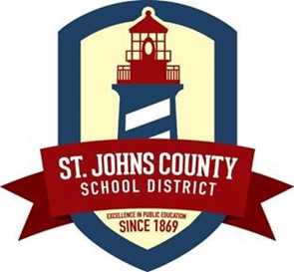

MEDICATION POLICY

Florida Statute 1006.062 authorizes school personnel to assist students in the administration of prescription medications. Parents/Guardians are encouraged to administer medications at home prior to or after school hours. The schools do not keep stock medicine in the clinic.

If your child needs medication during school hours, please note the following:

- All medications (prescription and over-the-counter) must have a medication form signed by both the parent/guardian and the physician ordering the medication. EXCEPTION: A student at the middle and high school level may carry a non-prescription; non-emergency medication on his/her person while in school with written permission from the parent/guardian. A copy of the signed permission form must accompany the stated medication at all times.

- All medications must be received in the original container with current Rx label including student’s name, dosage, frequency of administration, physician’s name, and expiration date of medication (the expiration date on the pharmacy label, not on the medication box, will be the expiration date). Over-the-counter medications must be in the original, unopened container. No medication will be given if presented at school in a plastic bag.

- Medications must be brought to school by parent/guardian. Please do not send any medications with your child in their backpack. Medications may not be brought to school by the student.

- Medication brought to school by a student will be kept in the clinic until a parent/guardian comes to the school with the required paper work. Without the required authorization, the student will not be given the medication during school hours.

- Medications should not be transported between home and school on a daily basis. Separate containers should be kept at home and at school.

- At the end of the school year, parents are responsible for picking up their child’s medication. Arrangements for medication retrieval must be made with school staff. Medication left on campus will be disposed of in accordance with federal guidelines.

The St. Johns County School nurses provide a vital service for our students. If you have any questions or concerns, please do not hesitate to contact Health Services at 904-547-7693.

